# Instructions for including Linux commands

It’s strongly recommended that you return to the[**Manage authorization**](https://www.coursera.org/learn/linux-and-sql/ungradedLti/483Kl/activity-manage-authorization) lab on managing authorization to include screenshots of your commands as entered in the Bash shell. If this isn’t possible, you can also type your commands in this document.

When including samples of Linux commands, consider the following:

* There are multiple applications that can be used to take screenshots. If you’re unsure how to take a screenshot on your device, you can perform an online search such as “how to take a screenshot in [your operating system].” Replace “[your operating system]” with the operating system your computer uses.
* Do not include the lab instructions on the right of the screen in your screenshots.
* For any typed commands, highlight your command in gray and use a monospaced font, such as in this example with another command: grep OS updates.txt.

**Navigating and checking permissions**

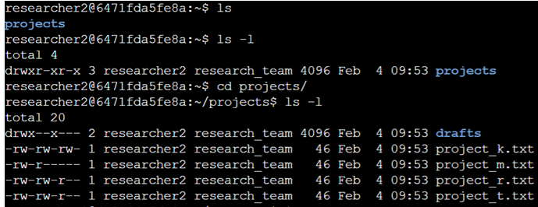

**Modifying permissions for files**

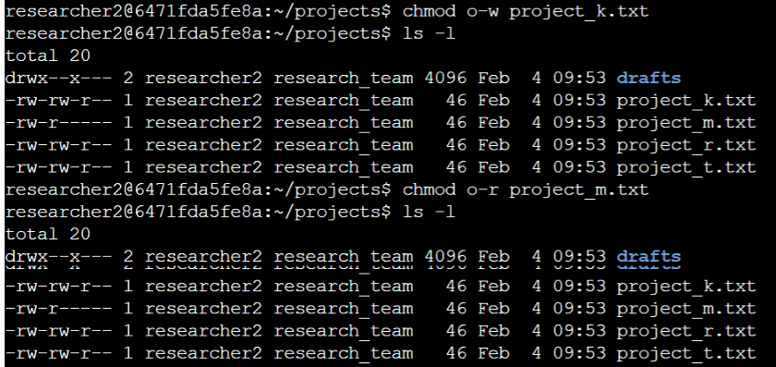

**Modifying permission for directory**

